**Longitudinal MLM Bonus Story Time: Practice Thinking about Time-Invariant Predictors**

Office Hours Continued Discussion: Treatment Effects in Persons with Severe Mental Illness

* ~24 persons initially, down to 12 by end of study; 3 occasions; multiple outcomes of mental health
* Treatment group occasions = before, after, follow-up; Wait-list control = before, before, after
* Research Question: Does treatment work?

Wave 1 Wave 2 Wave 3

**Treated** **Wait-List Control**

Workshop Participant Question: Effects of Remediation on Property Values

* Annual property values for two kinds of homes across 18 years: remediated or not
* Public meeting about need for remediation occurred in year 6; clean-up started in year 14
* 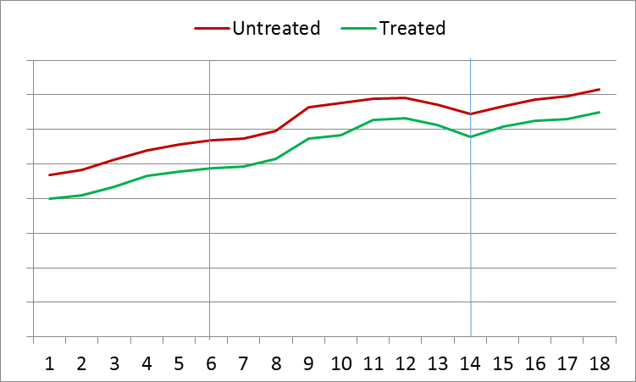Research Question: Did remediation harm property values? (see plot below of observed means)